DEVOPS

DAY 1 Task

1. Installing Docker
2. Create a file
3. Pull the image
4. Run the docker code

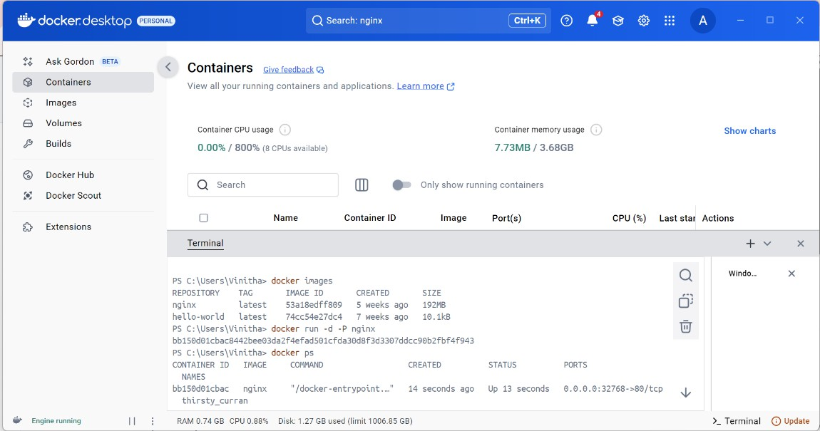

Aftre running the docker file, the output will be displayed in browser

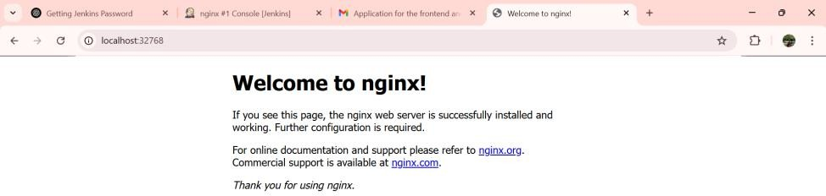

**Using Jenkins we are running the docker**

1. Installed Jenkins and ensured it was running.
2. Installed required plugins
3. Pull the image
4. Build now

